

Faculty of Science

**Course**: CSCI 2020U: Software System Development & Integration

**Instructor:** Rohollah Moosavi

**Semester:** Winter 2020

**Course component:** Test #1 – Part 2 (2 questions)

**Total mark:** 70 marks for Part 2 – each question 35 mark (Test #1 marks in total: 100)

**Duration:** 50 minutes for Part 2 (70 minutes in total)

**From 15.1 of your academic calendar:**

Academic misconduct includes, but is not limited to:

1. Unreasonable infringement on the freedom of other members of the academic community (e.g., disrupting classes or examinations, harassing, intimidating, or threatening others).

2. Violation of safety regulations in a laboratory or other setting.

3. Cheating on examinations, assignments, reports, or other work used to evaluate student performance. Cheating includes, among other things, copying from another student’s work or allowing one’s own work to be copied, submitting another person’s work as one’s own, fabrication of data, consultation with an unauthorized person during an examination, use of unauthorized aids, or submitting work prepared in collaboration with other member(s) of a class, when collaborative work on a project has not been authorized by the instructor.

4. Impersonating another student or allowing oneself to be impersonated for purposes of taking examinations, or carrying out laboratory or other assignments.

5. Plagiarism, which is the act of presenting the ideas, words, or other intellectual property of another as one’s own, including images, designs, processes, computer software, digital, audio and video files, Internet resources and other works without appropriate attribution or credit. The use of other people’s work must be properly acknowledged and referenced in all written material.

6. Obtaining by improper means examination papers, tests, or similar materials; use or distribution of such materials to others.

7. Falsifying academic records, including tests and examinations, or submitting false credentials for purpose of gaining admission to a program or course, or for any other purpose.

8. Misrepresentation of facts, whether written or oral, which may have an effect on academic evaluation. This includes making fraudulent health claims, obtaining medical or other certificates under false pretences, or altering certificates for the purpose of misrepresentation.

9. Submission of work when a major portion has been previously submitted or is being submitted for another course, without the expressed permission of all instructors involved.

Your Name:

Your Student ID:

Your TA name:

Question 1:

(Tic-tac-toe board) Write a program that displays a tic-tac-toe board, as shown in following Figure. A cell may be X, O, or empty. What to display at each cell is randomly decided. The X and O are images in the files **x.gif** and **o.gif**.

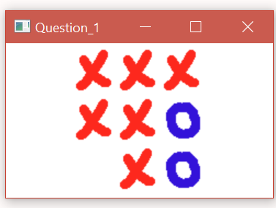

Question 2:

(Create a simple calculator) Write a program to perform addition, subtraction, multiplication, and division, as shown in following Figure.

